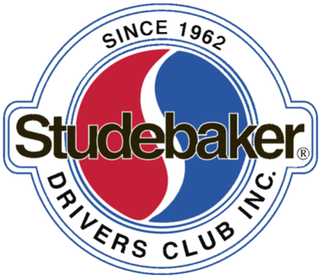

WE MISS YOU!

(Name),

It appears as though your Studebaker Drivers Club membership has not been renewed. As the SDC’s volunteer Regional Manager for your area, I am personally contacting you to let you know we would like to have you back “in the family”!

If you have inadvertently let your membership expire, I encourage you to call Cornerstone at your first opportunity to renew and keep our award-winning Turning Wheels magazine coming to your mailbox. Their email address is: mark@cornerstonereg.com and the phone number is 763-420-7829.

If your membership has been expired for a year or less, mention my name when you re-join. Mark will make sure your “member since” date will reflect your previous membership time versus starting over fresh!

If you had not renewed your membership for other reasons, it would be genuinely helpful if you could share the reason why you chose to leave the SDC. If you would be so kind as to contact me, I would personally appreciate it and it will be very helpful to the Club as it continues to strive to be of long-term service to its members.

Best Regards,

(RM name)
SDC Regional Manager – (Region/State or Province)
Address

Phone:
Email:

