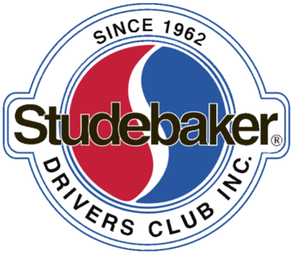

WELCOME TO THE CLUB!

(Name)

Thank you for joining the more than 9,000 Studebaker enthusiasts from around the world who are now your fellow members of the Studebaker Drivers Club!

As the SDC’s Regional Manager for (Your Region/State/Province), I want to personally welcome you. If you have not yet received your first issue of our award-winning Turning Wheels magazine, be assured it will be in your email, delivered to your street address, or post office box as soon as possible. It is a fabulous magazine you will look forward to receiving and reading each and every month.

If you have not already made contact with an SDC Chapter in your area I would be pleased to assist in that regard. A list of those chapters and the contact information for can be found on the SDC website: studebakerdriversclub.com. Chapter membership and participation is a fun, educational and positive way to enjoy “Studebaker Life”. Plus, you have the opportunity to network with club members, who can assist you in your search for resources to complete your restoration project.

If you have any questions, particularly about this region, its Chapters, Zone Meet and our National Meet, please contact me and I am happy to help. We Regional Managers, Zone Coordinators and National Directors are all volunteers who share a goal of making your membership in the Studebaker Drivers Club a rewarding experience.

Once again, welcome to our family!

Best Regards,

(Name)
SDC Regional Manager – (Region/State/Province)
Address

Phone
Email

